Aab e kor – eco friendly water bottle
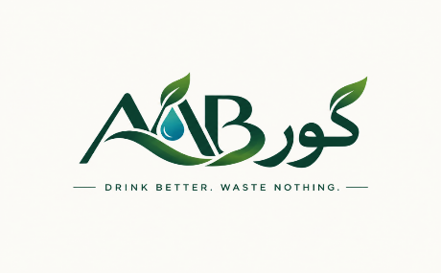

Product Description & Brand Product
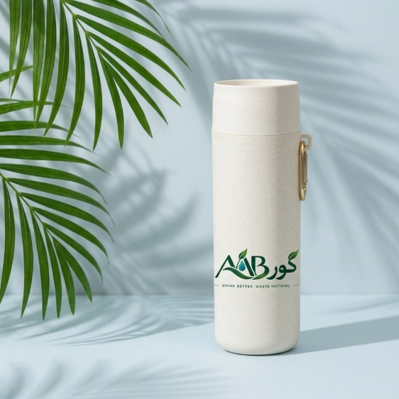

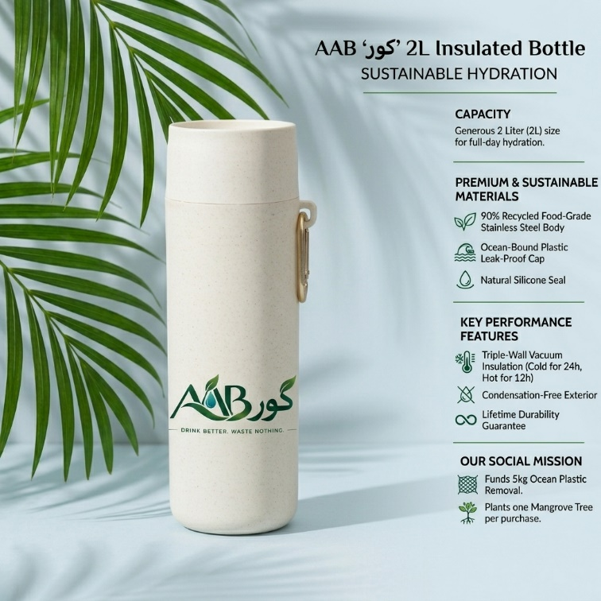

\
Product features
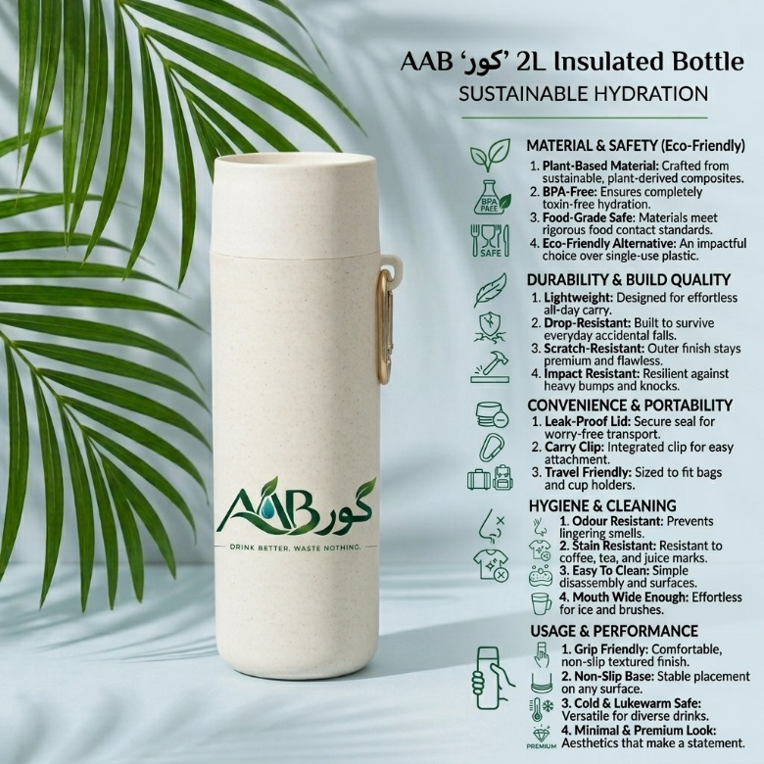

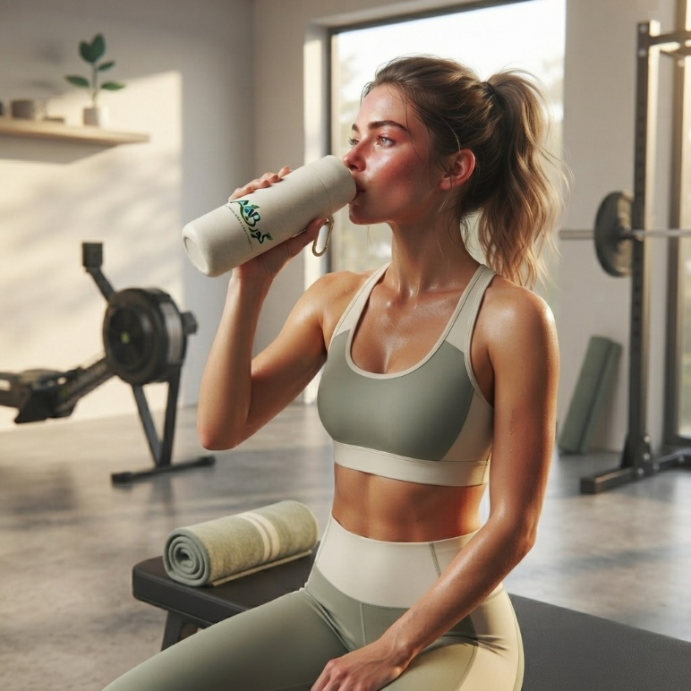
BLOG POST:
Post 1 (Instagram / Active Lifestyle & Fitness)
Caption: Post-workout refresh done right! 💦 Hydrate cleaner with AABکور. Lightweight, ultra-durable, and non-toxic. Clip it, sip it, reuse it. What’s in your gym bag today? Drop a 🌿 in the comments if you’re choosing zero-waste! #AAB کور #HydrateSustainably #FitnessGoals

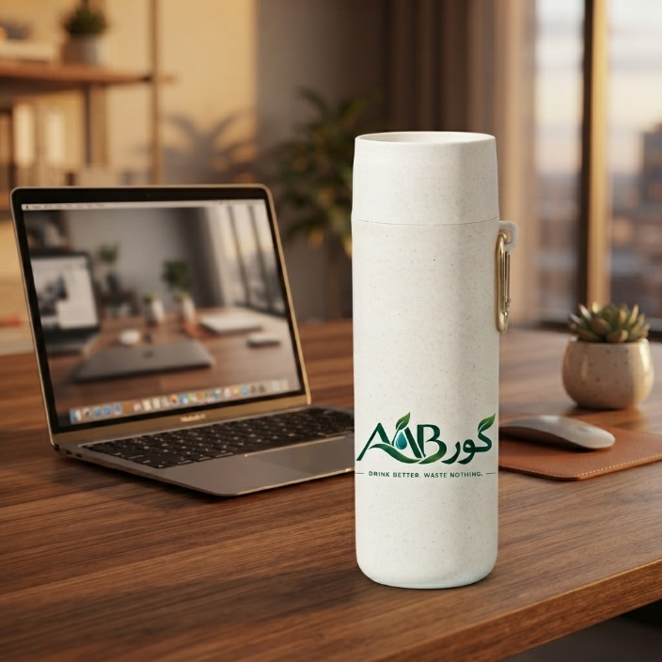
Post 2 (LinkedIn / Corporate Eco-Focus)
Caption: Is your workspace reducing single-use plastics? Transition your daily desk hydration to AAB کور crafted from sustainable plant composites designed for modern professionals. Upgrade your daily routine while keeping plastic out of oceans. 🌿 Modern design meets corporate sustainability.

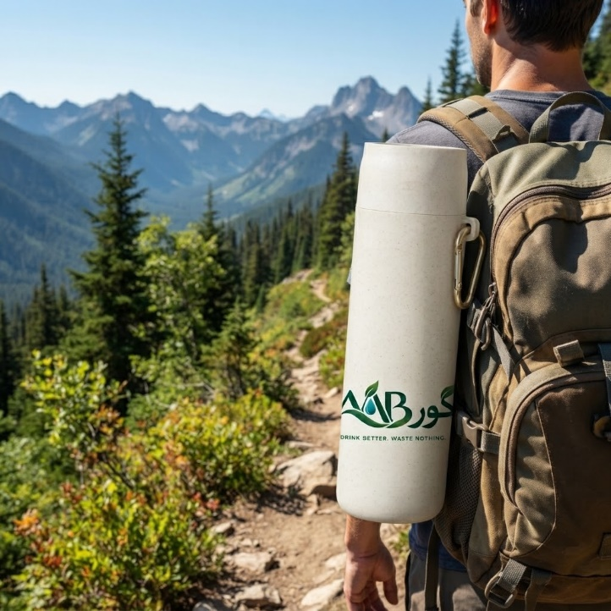
Post 3 (Twitter / X / Outdoor & Travel)
Caption: Ready for the trail? 🎒 Standard plastic bottles don't cut it in the wild. The AAB کور Bottle hooks directly onto your pack with a built-in brass carabiner so you can stay hands-free on every summit. Small choices = big impact. ⛰️🥾 #ZeroWaste #OutdoorGear #AAB کور

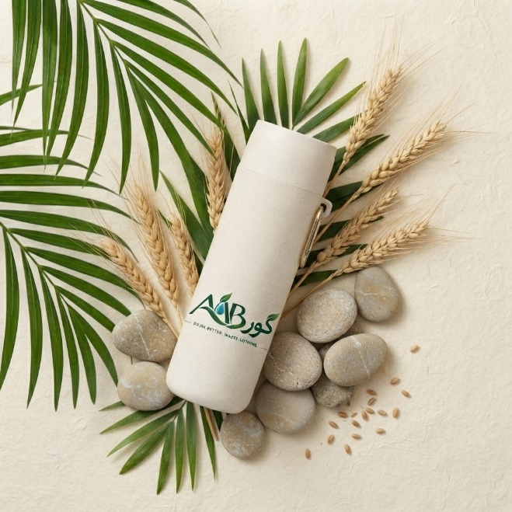
Post 4 (Facebook / Brand Aesthetics & Lifestyle)
Caption: Elegance meets environmental responsibility. The AAB کور Wheat-Straw Bottle isn't just a container—it's a statement. Sleek design, tactile matte finish, and zero single-use plastic. Order yours today and receive 15% off your first order! Link in bio. ✨

Content Type | Primary Goal | Tone & Style | Key Strengths | Limitations
Blog Post | In-depth education, SEO value, narrative building. | Thoughtful, editorial, inspiring. | High trust-building; addresses consumer skepticism; ranks on search engines over time. | Low immediate conversion; requires significant reading commitment from the user.
Product Description | Direct conversion, feature clarity, purchase validation. | Direct, punchy, benefit-driven. | Reduces buyer friction; scannable specs; answers buying objections instantly. | Dependent on existing traffic; doesn't generate top-of-funnel discovery alone.
Social Captions | Immediate attention, viral reach, community engagement. | Hook-heavy, aesthetic, conversational. | High shareability; native to where consumers discover products; immediate feedback loop. | Short shelf-life; limited space for complex messaging; highly reliant on visual assets.
Comparative Analysis of Outputs
Client Proposal Document
Proposal: AAB کور Brand Rollout & Digital Campaign Management
Prepared for: Potential Retainers / Distribution Partners
Prepared by: Brand & Digital Marketing Agency
Executive Summary
AAB کور is poised to capture the sustainable lifestyle segment with premium wheat-straw reusable bottles. This proposal covers initial digital branding, marketing rollout, content production, and distribution collateral.
Scope of Work & Deliverables
- Visual Identity & Packaging: Logo finalize, surface print proofs, and sustainable box packaging layout.
- Social Media Content Creation: 16 posts/month across LinkedIn, Instagram, Facebook, and Twitter.
- E-Commerce Conversion Optimization: High-converting product pages, email marketing automation (Welcome & Abandoned Cart series).
- Influencer Outreach: Tier 1 micro-influencer gifting campaign (Eco & Fitness niches).
Timeline & Implementation Schedule
Phase | Milestone | Duration | Estimated Delivery
Phase 1 | Brand Assets & Packaging Finalization | Week 1–2 | Day 14
Phase 2 | E-Commerce Landing Page & Copy Optimization | Week 2–3 | Day 21
Phase 3 | Content Production & Ad Creative Testing | Week 3–4 | Day 28
Phase 4 | Omnichannel Launch & Campaign Execution | Week 5+ | Ongoing
Estimated Cost Breakdown
Item / Service | Scope | Investment (USD)
Brand Identity & Packaging Design | Final vector assets, style guidelines, packaging | $1,200
Content Creation & Copywriting | 16 Visuals + Short/Long Copy + Blog series | $1,500
Ad Campaign Management | Meta & Google Ads setup + optimization (1 Month) | $1,000
Influencer Seeding & PR | Management for 20 eco-influencer giftings | $800
Total Estimated Investment |  | $4,500

Professional Bidding Email
Subject: Bid Submission: Full-Scale Marketing & Brand Campaign for AAB کور Bottle
Dear [Client Name / Selection Committee],
I hope this email finds you well.
We are excited to submit our formal proposal for the brand rollout and digital marketing campaign for the AAB کور Eco-Friendly Bottle. Having analyzed your product’s unique selling proposition specifically its plant-composite construction, minimalist aesthetics, and integrated portability features we have developed a multi-channel content and growth strategy tailored for rapid customer acquisition.
What We Have Prepared for Your Review:
- Brand Storytelling & Copy: A complete blog series, conversion-focused product descriptions, and tailored social media captions.
- Visual Campaign Strategy: High-impact lifestyle and product imagery designed for Instagram, LinkedIn, Facebook, and Twitter engagement.
- Comprehensive Proposal & Schedule: A detailed scope of work outlining milestones, cost structures, and deliverables for seamless execution.
Our team specializes in scaling eco-conscious direct-to-consumer brands through high-converting creative assets and performance marketing. We are confident this proposal aligns perfectly with AAB's growth objectives.
Please find the proposal attached, and feel free to schedule a call via the link below to discuss the next steps.
Best regards,
[Your Name / Title]
[Your Agency / Firm Name]
[Contact Information / Portfolio Link]

